EXDON 04.10.2024
Identify the possible Entities, their Attributes and the relationships between the entities from each of the following given scenarios. Construct your ERD following diagramming convention. Write the sentences for each relationship, in both directions.

1. The management of an airport has decided that all information related to the airport's activity will be managed using a database. Each aircraft has a registration number and a model. The airport has some aircraft models, and each model is identified by a code (eg DC-10) and has a certain capacity and weight. At the airport work many technicians. About them, we must know the name, id, address, telephone number and the salary.
Each technician is an expert on some aircraft models. Traffic controllers must have thorough medical control. For each traffic controller, we must know the date of the latest medical check.
The employees of the company (including the technicians) could be members of one of the existing unions. For each union member, we must know the name of the union of which he is a member, the date on which he registered and the number of the card. Several tests apply to airplanes to check their technical status and to issue the flight authorization for that aircraft.
Each test is identified by a code, a name and the maximum possible score and the minimum score necessary for the flight authorization to be issued are known. It is necessary to memorize the date when a particular test was applied to an aircraft, the score obtained, and it is necessary to know who the technician is who took care of the application of that test and how long the test lasted.

Technician – Aircraft Model:
Each Techician can be an expert in one or more Aircraft model. Each Aircraft Model must have one or more Techician.
Aircraft - Aircraft Model
Each aircraft must have one and only one Aircraft model. Each Aircraft model can have one or more Aircraft
Technician – Test:
Each techician can work one one or more test. Each test must have one and only one techician.
Test – Aircraft:
Each aircraft must have flight authorization by one and only one test. Each test must give one or more authorization for a Aircraft.
Union Member - Employees:
Each employee can be a member of an union. Each union can have one or more employee
Union Member -Technician:
Each Technician can be a member of an union. Each union can have one or more Technician.
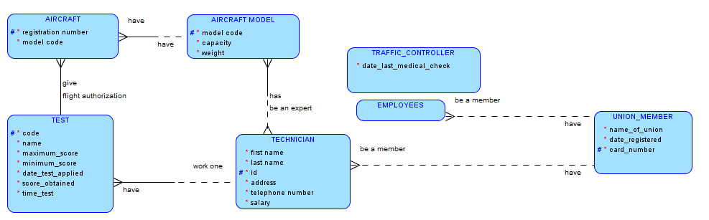
2. BOOK.COM is an online store on the Internet where customers can browse the catalog and select products of interest.
Every book has a title, ISBN, year and price. The store also keeps the author and publisher for any book. For authors, the database keeps the name, address and the URL of their homepage. For publishers, the database keeps the name, address, phone number and the URL of their website.
The store has several warehouses, each of which has a code, address and phone number. The warehouse stocks several books. A book may be stocked at multiple warehouses.
The bookstore keeps the name, address, email-id, and phone number of its customers. A customer owns several shopping carts. A shopping cart is identified by a Shopping_Cart_ID and contains several books. More information will be needed to complete the transaction.
Usually, the customer will be asked to fill or select a billing address, a shipping address, a shipping option, and payment information such as credit card number.
Book – author:
Each book must have one and only one author. Each author must own one or more books.
Book – publisher:
Each book must have one and only one publisher. Each publisher must have one or more books.
Book – warehouses:
Each book can be stocked at one or more warehouses. Each warehouse can stock one or more books
Book - shopping cart:
Each book can be in one or more shopping cart. Each shopping cart can contains one or more books.
Customer - shopping cart:
Each customer can own one or more shopping cart. Each shopping cart must have one and only one costomer.
Customer – billing address:
Each customer can fill one and only one billing address. Each billing address must belongs to one and only one custumer.
